STEPS TO INSTALL QT VIDEO PLAYER

1. Step 1: Open Your Mail

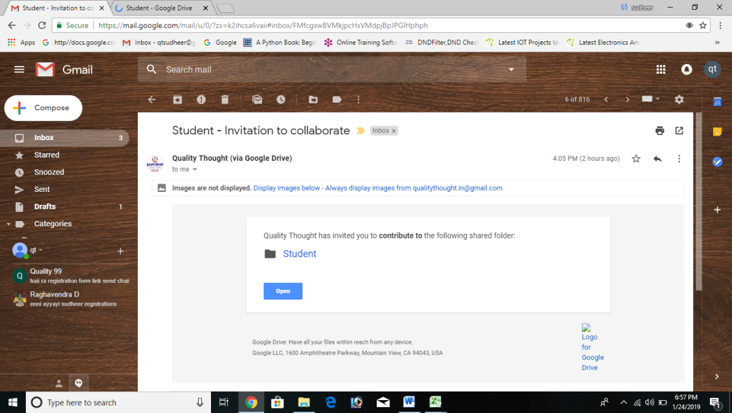

1. Download Software’s (QT Video player, Setup file )

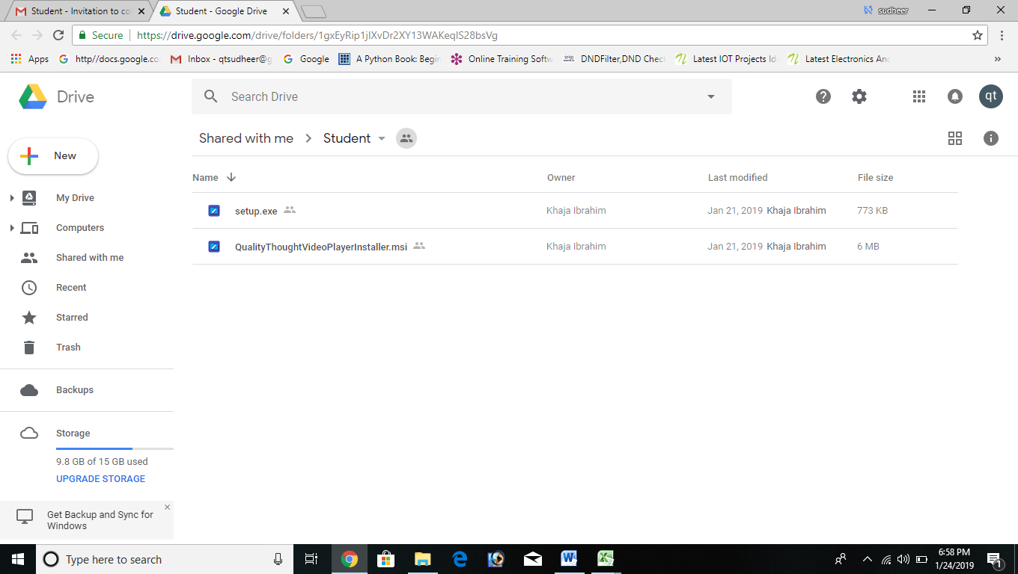

1. Install Setup file

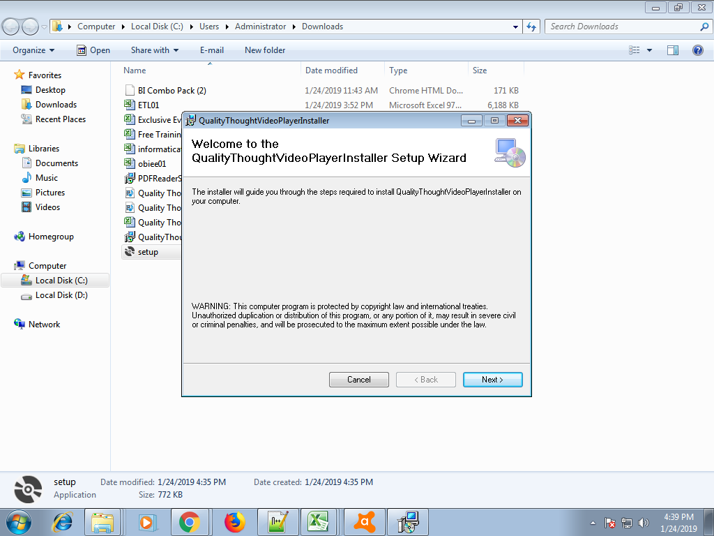

1. Click On Next

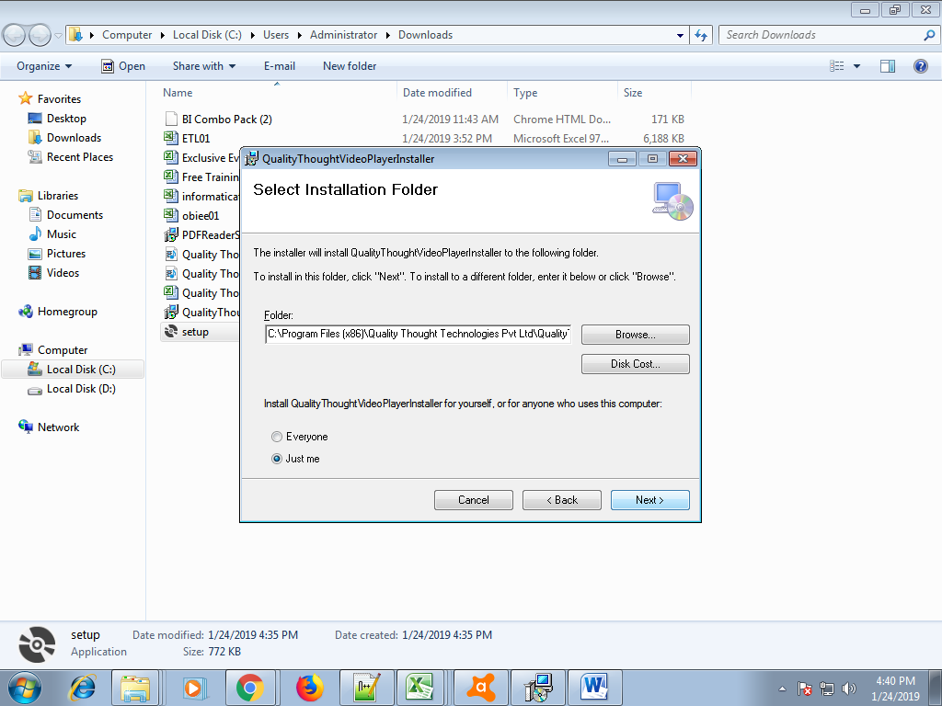

1. Again Next

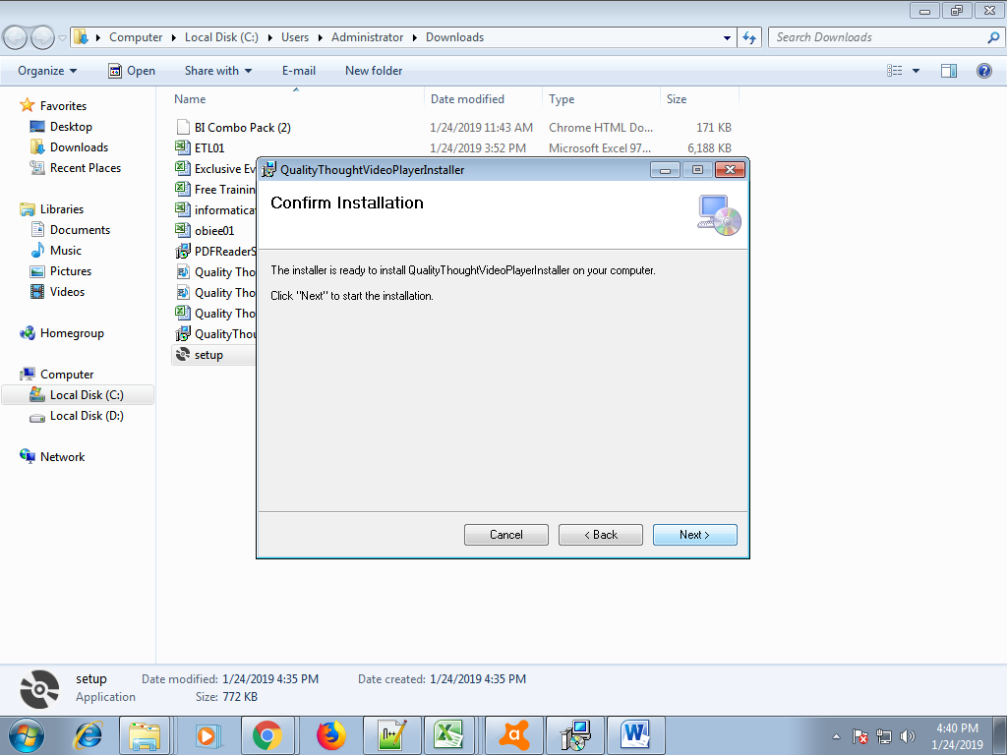

1. Wait Until the installation completes

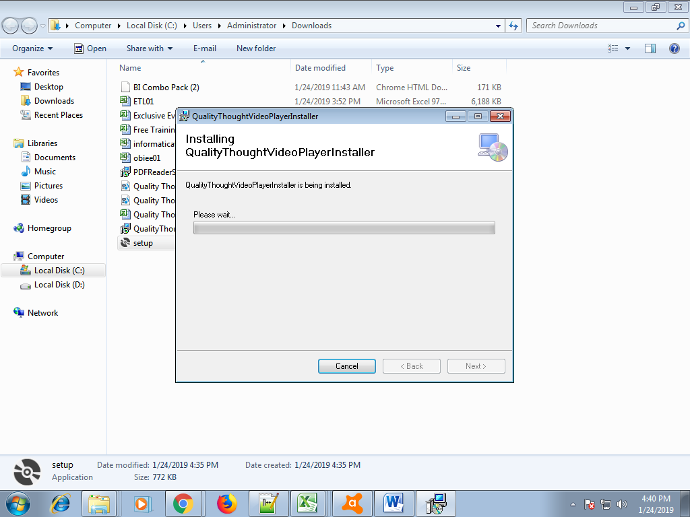

1. Install Quality Thought Videoplayer

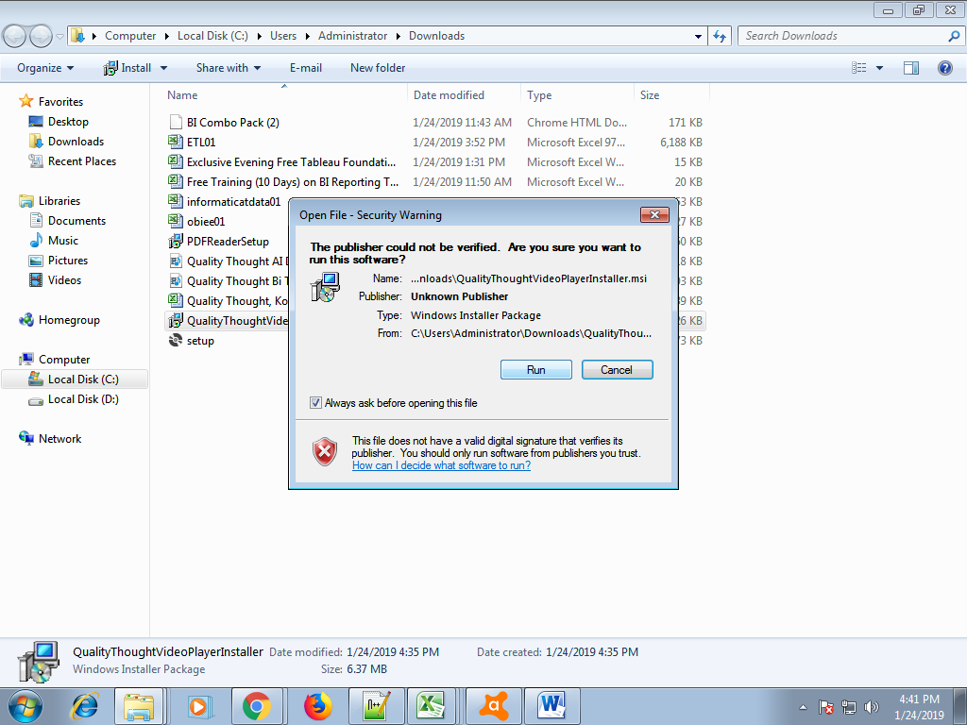

1. Select Repair QT Video player and then click on Finish

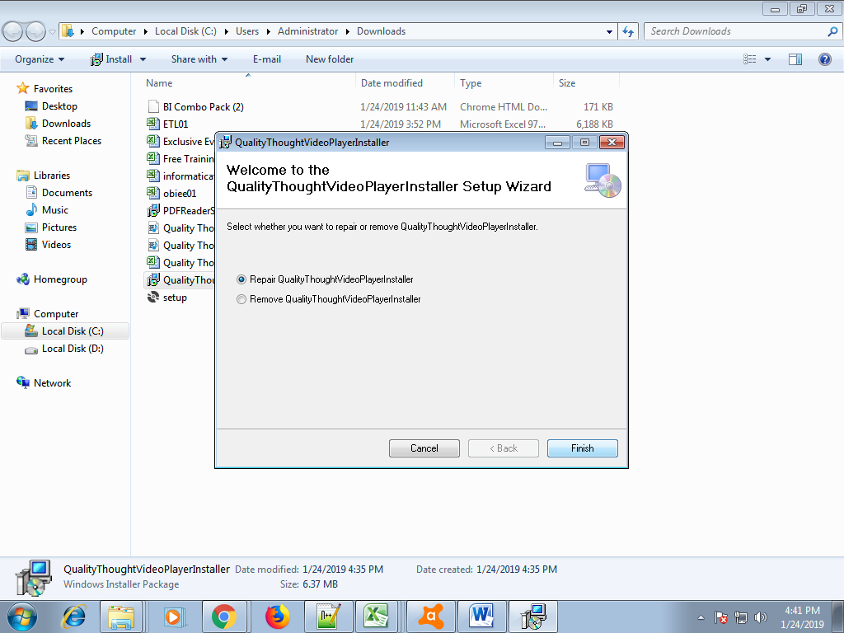

1. Close the file

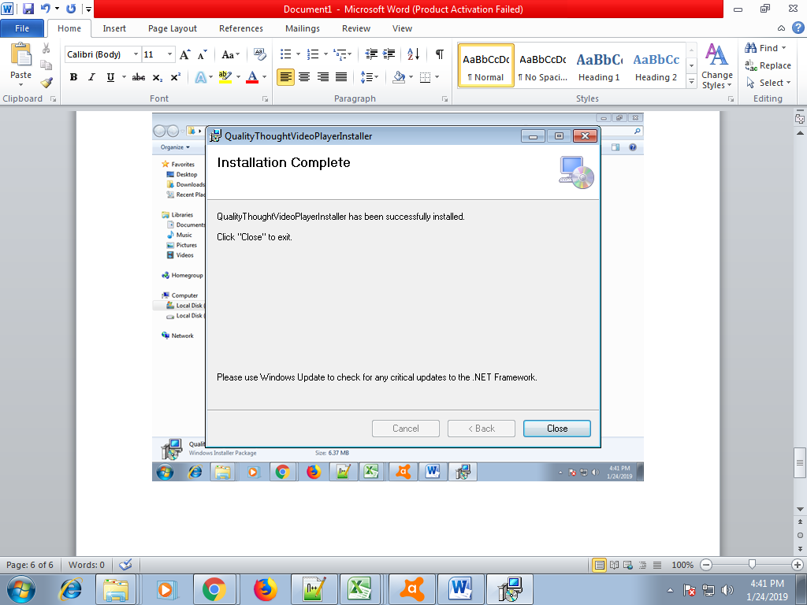

1. QT Video Player shortcut application will be created on your desktop
2. Right click on that icon and then go to properties

12) Click on compatibility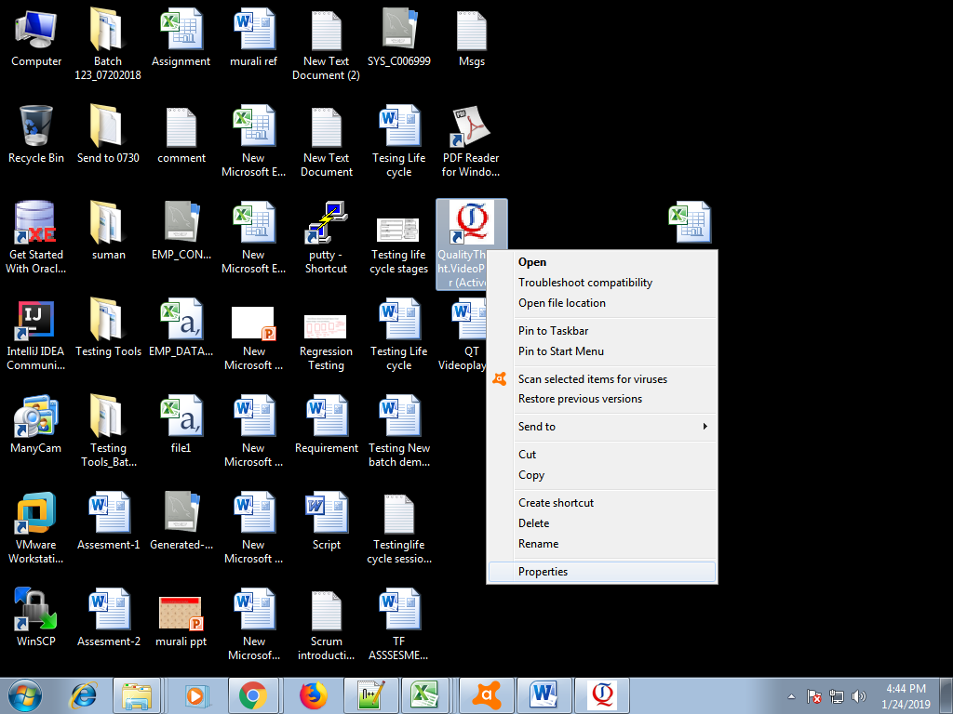

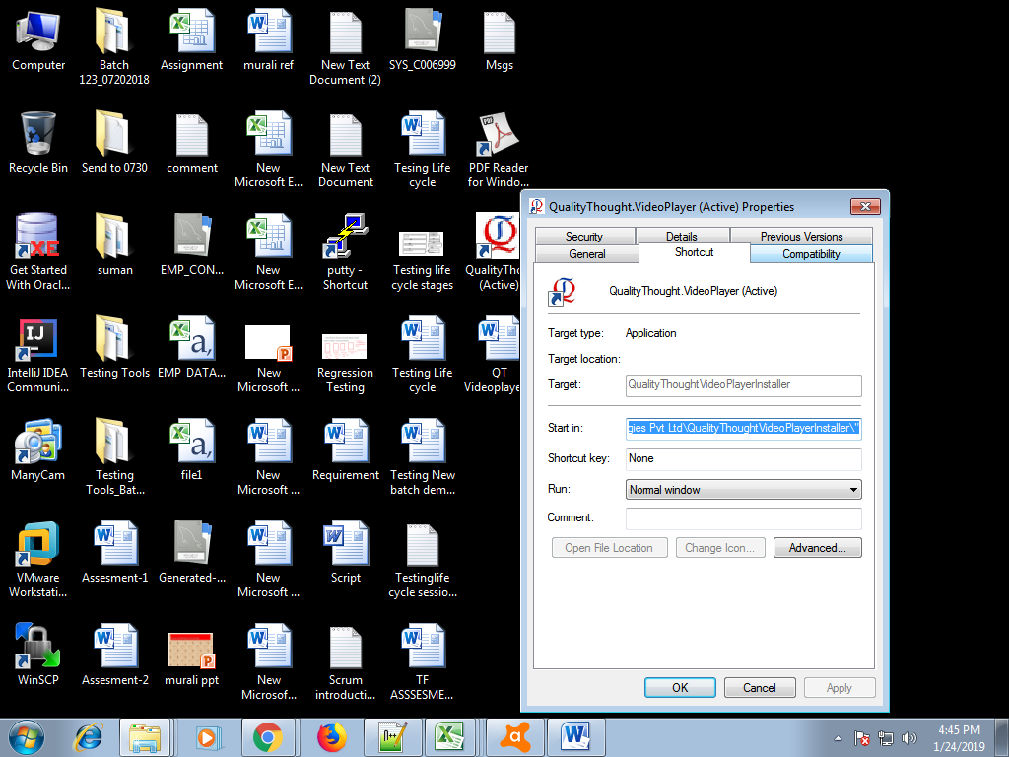

1. Click on run this program as an administrator
2. Click on Apply and then ok

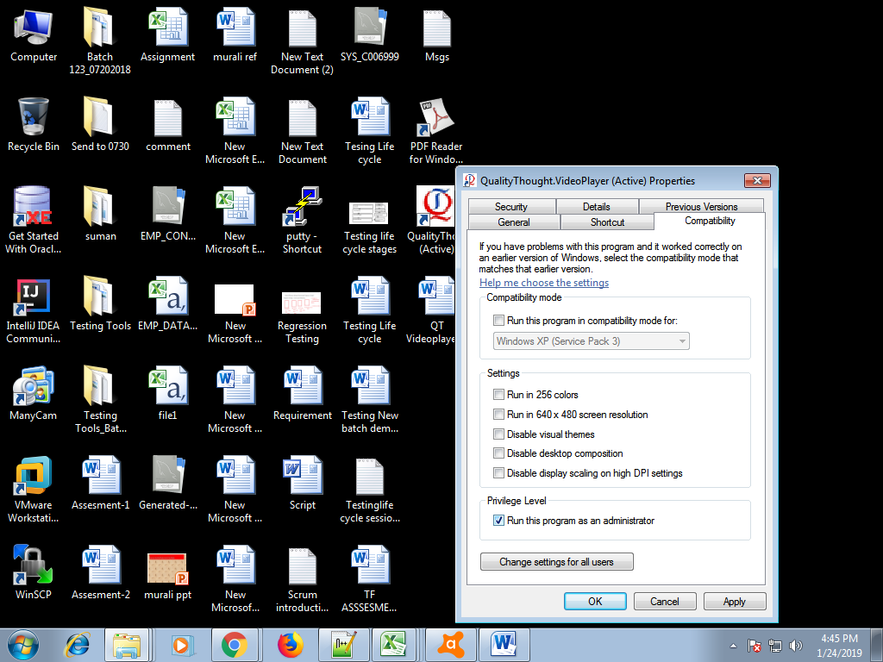

1. Double Click on QT Icon and copy the user key

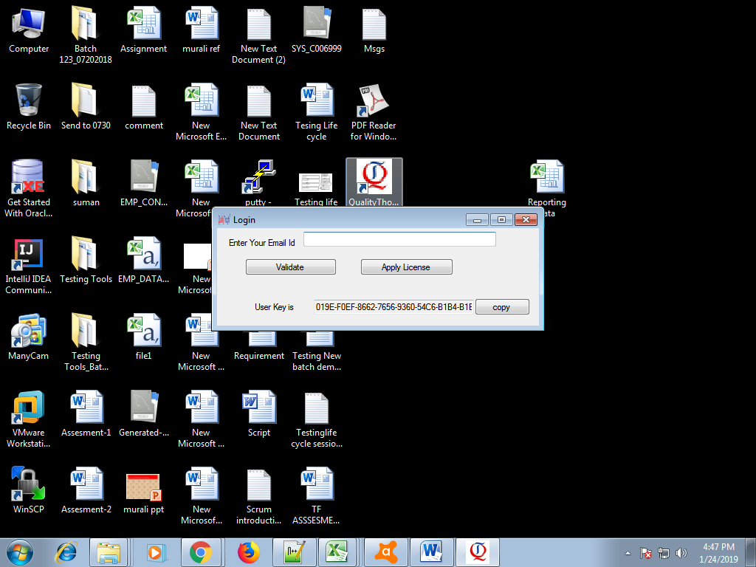

1. Send the key to [sathish@qualitythought.in](mailto:sathish@qualitythought.in)
2. Name:---,Courses:-----
3. In that mail please mention your Name , Mobile number, Email ID, Please Share Your System Product ID: follow below Screenshot

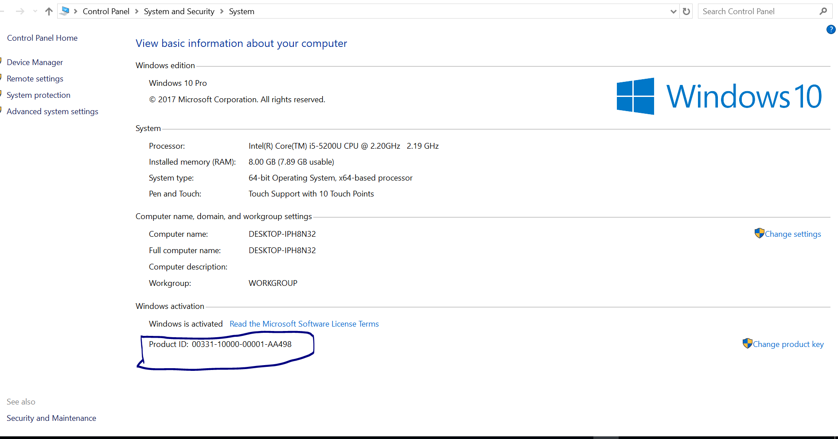

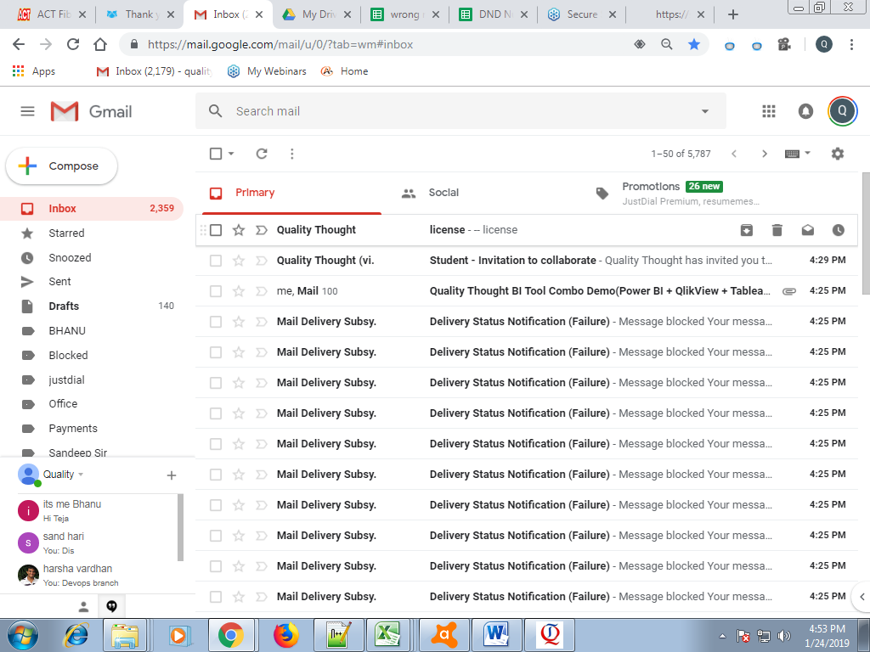

1. You will Receive licence from [qualitythought.in@gmail.com](mailto:qualitythought.in@gmail.com)
2. Download the received licence

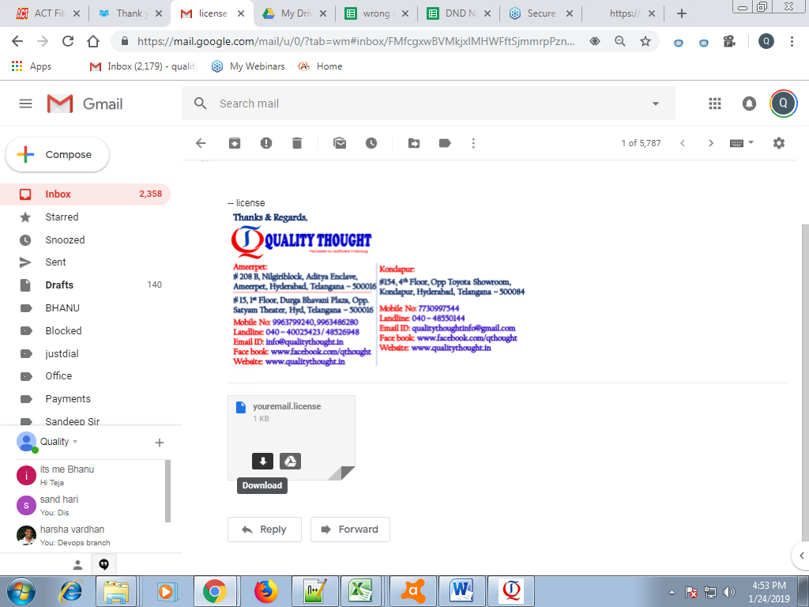

1. Open the downloaded license

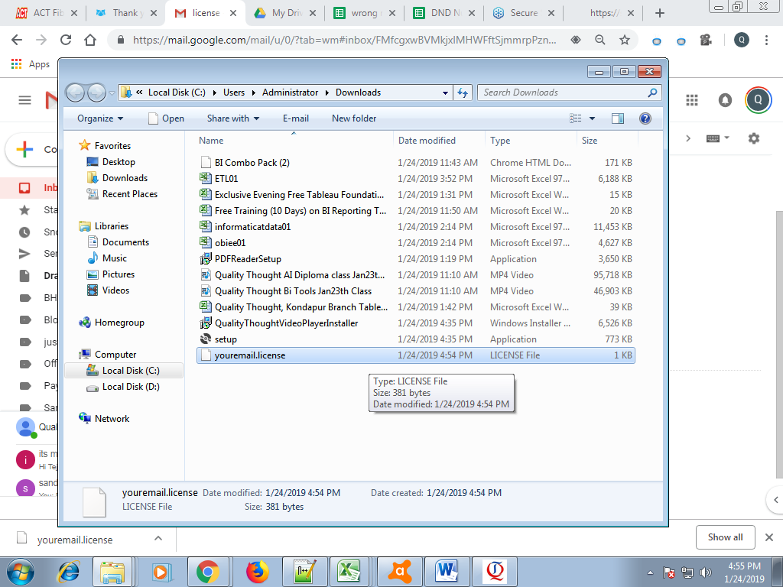

1. Login with your mail (this mail id should be same as that of your registered mailid)
2. Click on Apply License

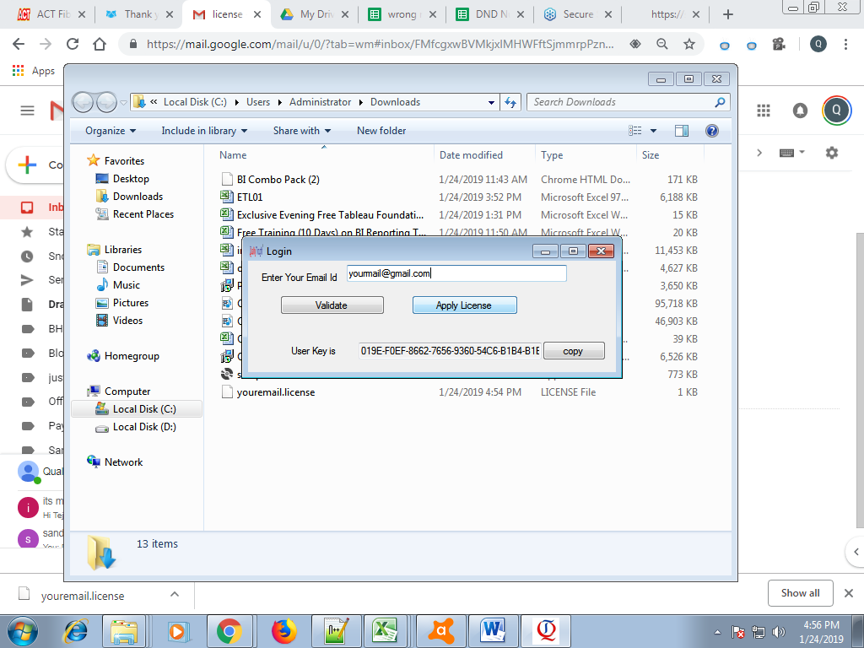

1. Select the license and Click on Open

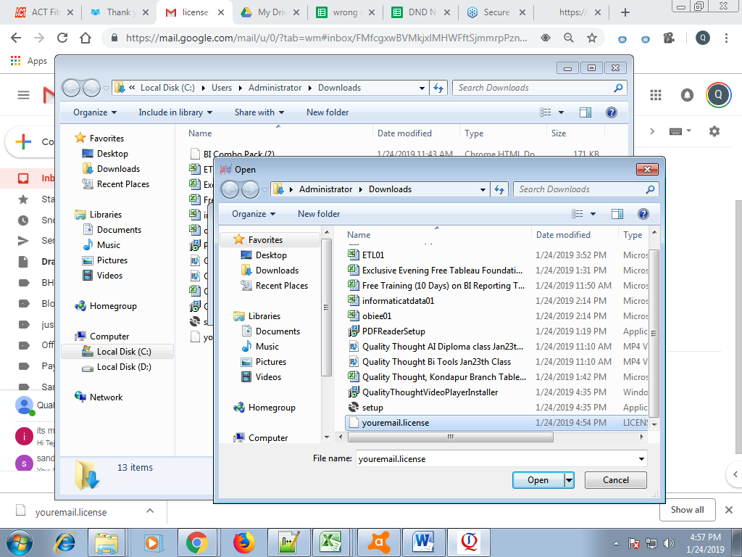

1. Click On OK

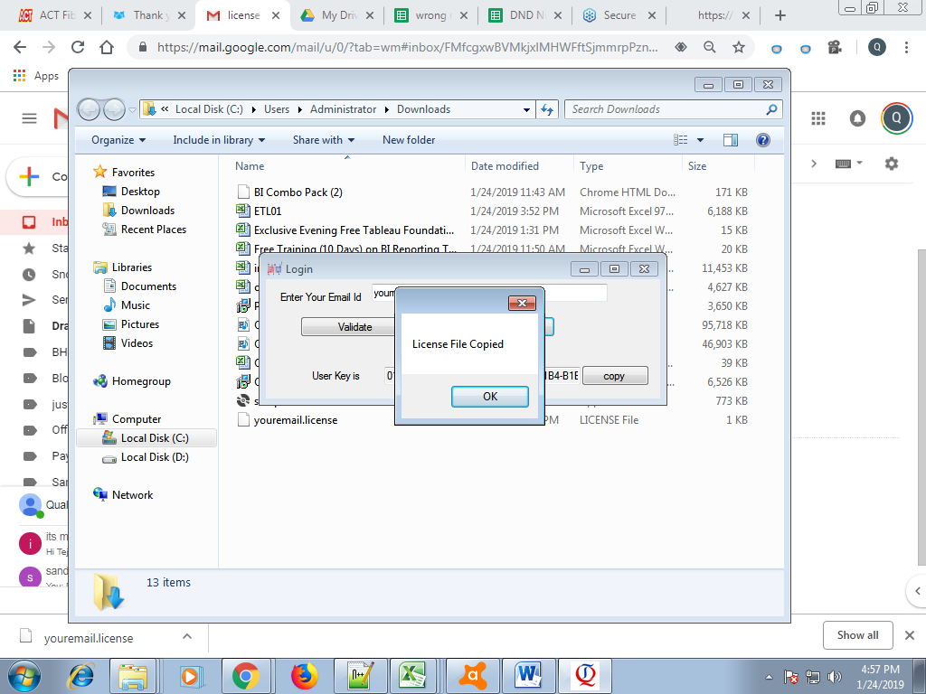

1. Every day we will share the videos and we will give the access to download
2. Go to mail and download the video

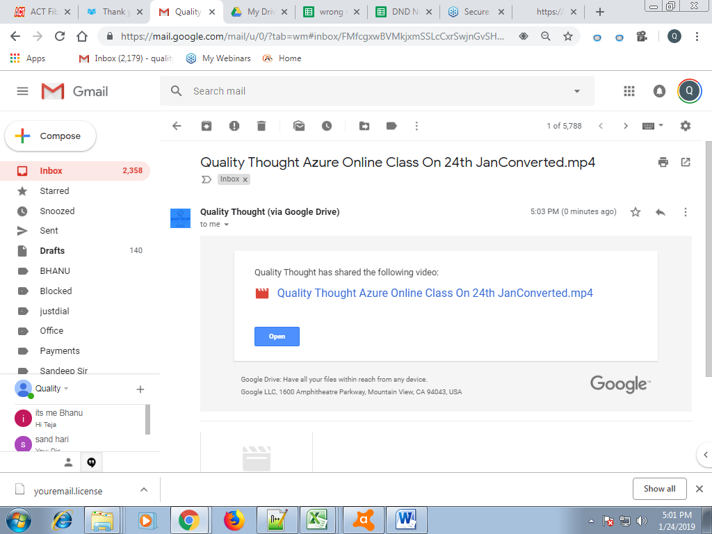

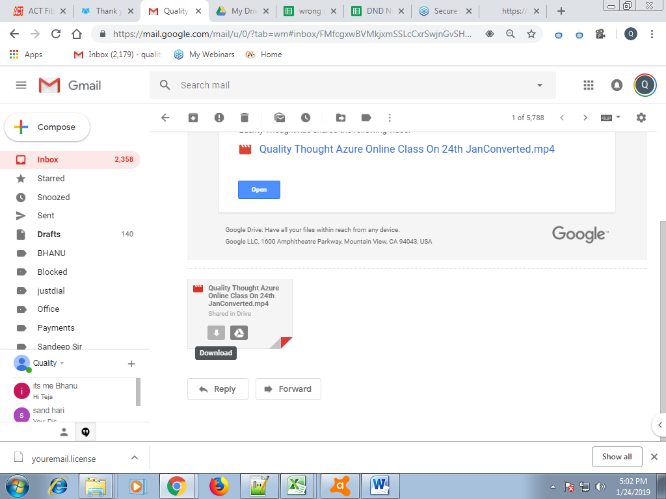

1. Again Open the application

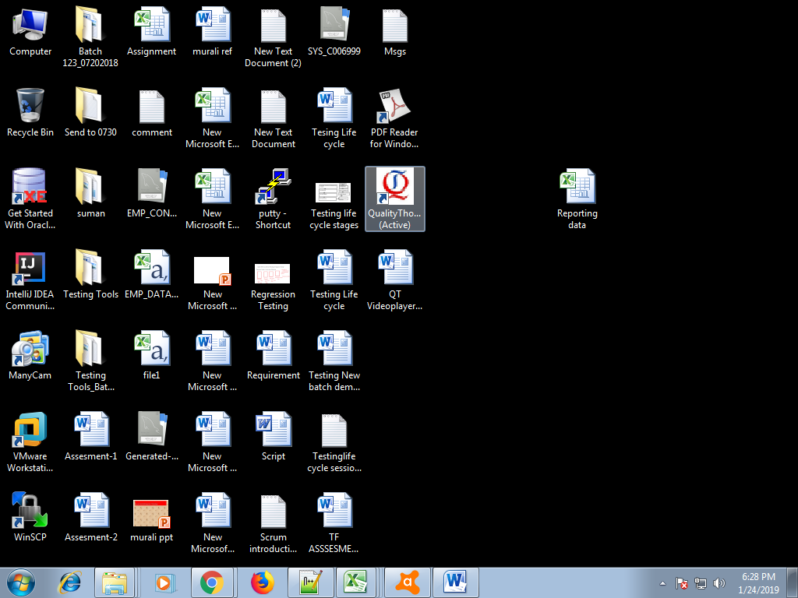

1. Login with registered email only and click on validate

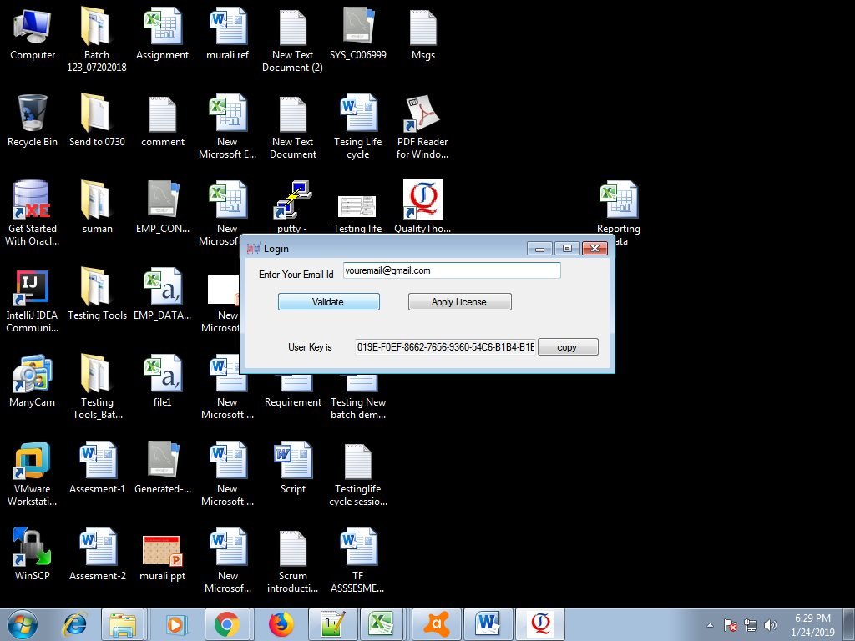

1. Browse the path of the downloaded video

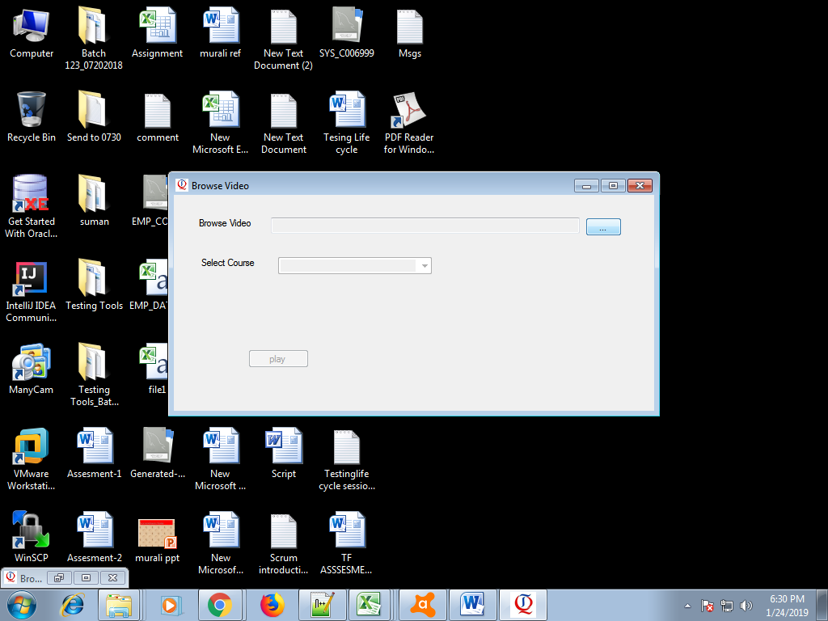

1. Select the required video and then click on open

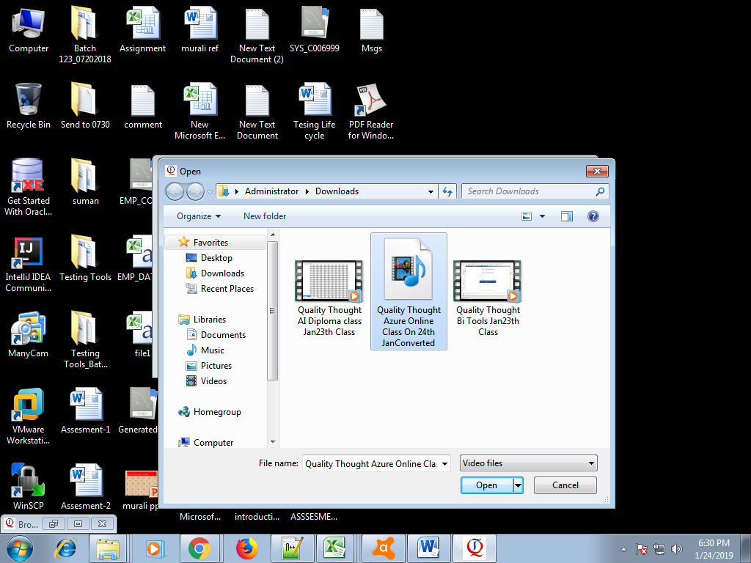

1. Select the course name related to the video and then click on play

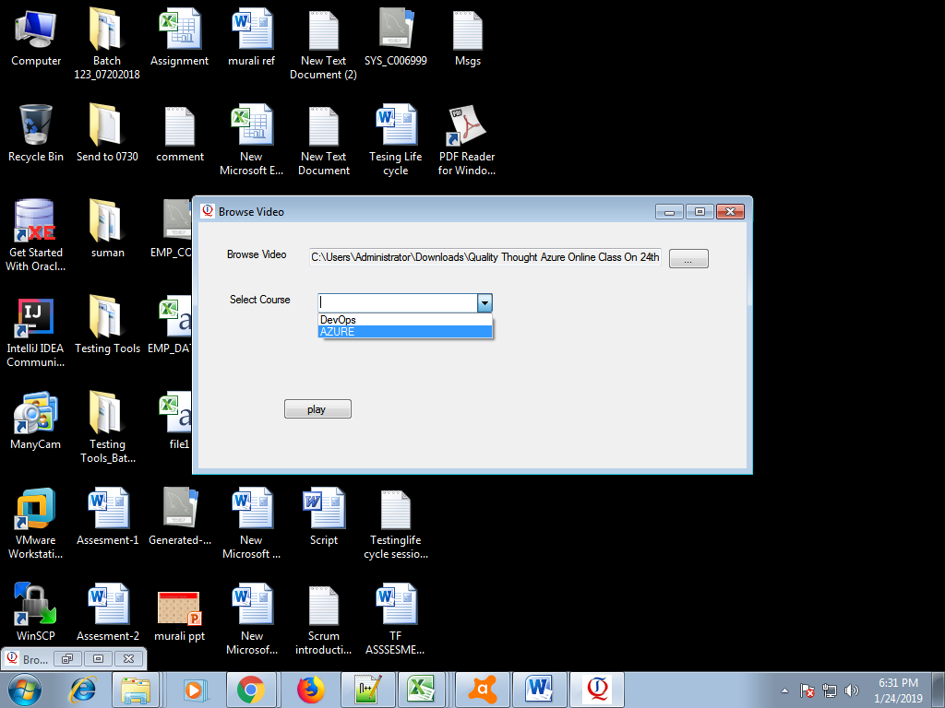

1. Then the video will be played

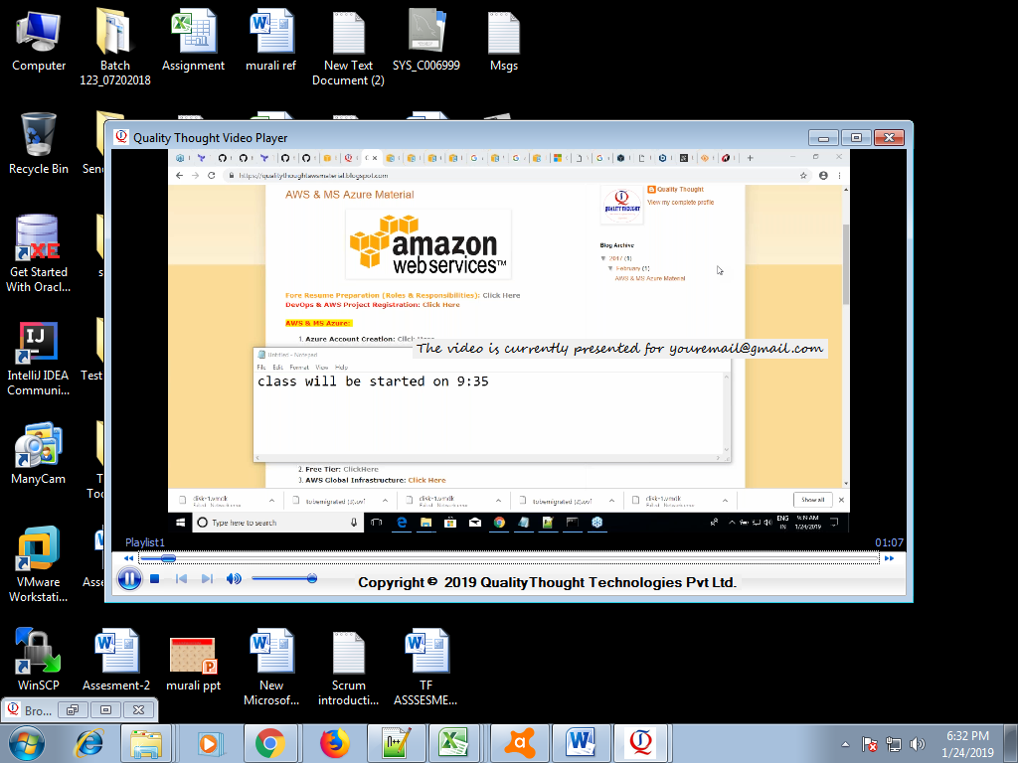

1. 

<https://support.microsoft.com/en-in/help/15090/windows-7-install-service-pack-1-sp1>